Welcome to over 40 years of racing with


The Keith Hall Memorial 10km & Fun Run
22nd March 2026 - Pre-race Information

Our race will open on Dec 1st and can be entered via https://totalracetiming.co.uk/race/652

Please note – in 2026 we will be an Age Group Masters qualifying race with England Athletics, and as such we expect to sell out very quickly. Please don’t delay entering. Total Race Timing will operate a waiting list.

What time does the race start?
The Keith Hall Memorial 10km race starts at 10:30am just outside our race headquarters, Bedford Hall (PE6 0QE).
The 3km Fun Run starts at 9:30 in Thorney Park and is a good 10-minute walk away from the race headquarters at Bedford Hall.
The parking area is 22 mins walk away from race HQ, so please allow plenty of time.

Where can I park?
Parking is at the other end of Thorney village at Park Farm (the same as 2025). Please allow enough time to walk the 1 mile through the historic and picturesque Fenland village. Parking is extremely tight, so please car share as much as possible. Please do not drive through the village itself. Ignore your Sat Nav instructions and follow the signs to the car park.

Parking is available at ….. 7 Park Farm off Deer Park Way, Thorney, Peterborough, PE6 0SY
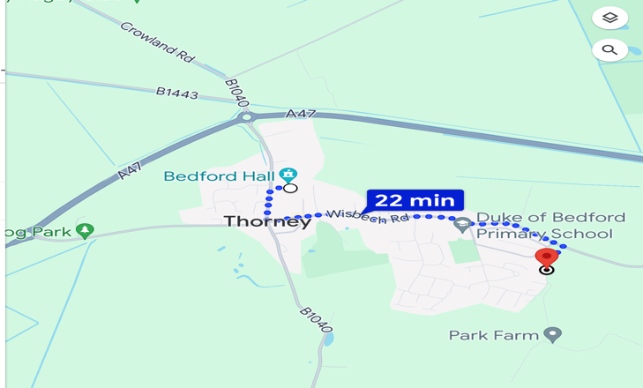
What3words…. rails.flinches.witless

When will I get my race number?
We do not send race numbers out by post before the race. Race numbers have the chips attached and need to be collected from Bedford Hall on race day (22nd March 2026). Prior to race day you will receive an email with notification of your race number. On arrival at Bedford Hall please head to any of the collection desks and ask for your number. Please check your email prior to coming to Thorney as the mobile networks aren’t good in the village. The Fun Run is not chip timed but is officially timed.

I would like to enter the 10k on the day. Can I do this?
NO! THERE ARE NO ENTRIES ON THE DAY! We will sell out very quickly in December.
Entries can only be made in advance via https://totalracetiming.co.uk/race/652

How can I enter my child in the Fun Run?
You can only enter the Fun Run on the day. There are NO advance entries for the Fun Run. You can enter either at Bedford Hall, or up at the park. Fun Run entries £4 each. Please note…CASH ONLY…we do not have the facilities to take card payments. There is no cash machine in Thorney village.

What facilities are there on race day?
There are lots of facilities at Bedford Hall. There is a large seating area, toilets, and an extensive range of home-made refreshments will be on sale. Please bring CASH for refreshments. We do not have facilities to take card payments. Please note there are no showers. There is no official baggage drop off, but bags can be left at Bedford Hall at owners’ own risk.

What prizes are available?
All 10k finishers will receive a medal.
The following prizes are also awarded for the 10km event.

Male | Female
1st place | 1st place
2nd place | 2nd place
3rd place | 3rd place
MV40 | LV35
MV45 | LV40
MV50 | LV45
MV55 | LV50
MV60 | LV55
MV65 | LV60
MV70 | LV65
1st team of 3 | 1st team of 3

I might win both the race, and an age category prize.
This is not possible at our races. The first three overall places take precedence over age prizes and you cannot win both. You will win the race, and the age prize will go to the next fastest runner in the age group.

Do you use Gun Time or Chip Time?
The first three podium places for both men and women are awarded on Gun Time. The Age Category prizes are awarded on chip timing.

What are the rules regarding the team prizes?
To qualify as part of a team you must be wearing team kit and must be registered as a club member when you enter our race. You must be a paid-up member of your team with a URN number. We cannot enter you retrospectively in a team. Team prizes are calculated on cumulative chip times of the first three athletes.

Is the course measured accurately?
Yes. We follow strict guidelines and the Certificate of Course Accuracy will be displayed at Bedford Hall, along with maps, insurance, and our UKA race licence.

Are the roads closed?
Yes. All the roads you will be running on will be fully closed to traffic (apart from emergency vehicles) between 10.30 and 11.30am. We no longer have a police presence due to a new policing policy, but our marshals are trained, and local residents are well informed of the closure. If you think you will take longer than 1 hour, please don’t worry. We encourage runners of all ability and pace, but as we must open the roads at 11.30am, we will ask you to run on the pavement once the roads have been re-opened. Our marshals will still be supporting every runner and will not leave the course until every runner has finished the race.

Is water available?
Yes, there will be a water station just after halfway out on the course on the return home, and water will also be available at the finish line.

Can I wear my headphones and listen to music?
Only bone conductor headphones are allowed. It is against UKA rules to run in a road race with ‘in ear’ headphones (unless worn for a medical reason). You will not be able to hear other runners and emergency instructions from marshals, and it is unfair on other runners. Please note that if you wear ‘in ear’ headphones, you run the risk of being disqualified from our race..

Are pushchair and buggies allowed?
Unfortunately, not. Part of the course (Old Knarr Fen Drove) is very narrow with runners in both directions. Due to nature of the Fens, the road surface is too uneven for pushchairs and buggies on crowded roads. We have regrettably made this decision in the interest of safety for all our competitors. However, the FunRun in the park is open to pushchairs and buggies, but please note that the FunRun course is all on grass.

Can I enter in my wheelchair?
Unfortunately, not. Part of the course (Old Knarr Fen Drove) is very narrow with runners in both directions. Due to the nature of the Fens, the road surface is too uneven for wheelchairs. We have regrettably made this decision in the interest of safety for all our competitors.

Is The Keith Hall Memorial 10km race part of the Cambs AA Road League?
Yes, our race is part of the Cambs AA Road League. Details of the league and other races in the league will be available shortly.

Fun Run Information

How can I enter my child in the Fun run?
You can only enter the Fun Run on the day. There are NO advance entries. You can enter either at Bedford Hall, or up at the park. Fun Run entries £4 each. Please note…CASH ONLY…we do not have the facilities to take card payments. There is no cash machine in Thorney village.

I think my child has been entered in the wrong age group.
New junior age categories come into effect on 1st April 2026. However, on 22nd March 2026 we will be using our traditional age categories of Under11, Under 13 and Under 15. At Thorney Running Club we calculate ages as on race day, not on school years. So, a junior running in the U13 school team may not actually be under 13 on our race day. They may be in school Year 9 but could be 14 years old and will therefore be placed in the U15 age category in our event.

What prizes are available at the Funrun?
All finishers will receive a medal and a certificate detailing their time. We also award junior prizes for fastest boy and girl in age categories Under 11, Under 13 and Under 15. Please remember we calculate age on race day, not on school year.

What else do we need to know?

Water will be available at the Funrun finish line.

The Fun Run takes place in Thorney Park and is completely off road.

The Fun Run in the park is open to pushchairs and buggies, but please note that the Fun Run course is all on grass.

Please note that the Fun Run is well marshalled, however, it is a public park and adults are welcome to supervise their younger children.

